About Our Family Photos
Imagine my surprise, when looking for photos to include on the Victory Vintage website, I discovered that my love for hats, clothing & accessories, was actually passed down from my great great-grandmother! I discovered that around the turn of the century, my great great-grandmother, Jeanette "Nettie" Glass owned a millinery (hat) shop in Winfield, Iowa. This discovery shows that my love for hats and all things Victorian is truly a part of my destiny!
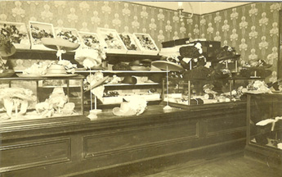 | We wanted to use family photos to start off our website with a "period" feel and also show you some of our heritage. The following gives you a brief description of the photos. We hope this stirs some interest in the Victorian & Old West periods through the vision of our heritage and also encourages you to dig into your own past to see what exciting secrets about your past, your present and your future await you!

Welcome to Nettie Glass' Millinery Shop in Winfield, Iowa around 1900. When researching my family photos for the website, I discovered that Nettie, my Great Great-Grandmother had owned and operated this millinery shop, making bold and outrageous hats. What a discovery and confirmation of my destiny to love, collect and sell hats & other Victorian wares! In addition to the photo, my Grandma Mary still has some of the netting used in some of Nettie's original millinery creations! What an exciting piece of my past! I believe that my love for hats would make Great Great-Grandma Nettie proud! Nettie (Jeanette) Glass was married to John Alvin ("Al") Glass. They had 2 daughters, Lucille & Helen. Lucille is the mother of Mary, who is my mother's mom. Grandma Mary still lives near Winfield, Iowa where she was married to my Grandpa Bill Wintermeyer in 1940 ~ they have enjoyed 65 years of marriage!

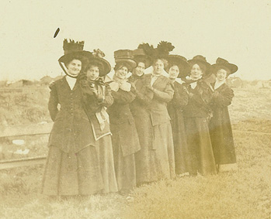 | These fine ladies were customers of Nettie's Millinery Shop. These were all hats made by Nettie! This could very well be me & the ladies of Miss Kitty's Social Club! What an inspiration for meÖto have this kind of knowledge and proof of my ancestry! This also goes to show the importance of preserving family photos, even if you don't know all of the folks in them!

Source:
http://images.google.com/imgres?imgurl=http://store.victoryvintageonline.com/merchant2/graphics/00000001/photos/NettieG.jpg&imgrefurl=http://store.victoryvintageonline.com/merchant2/merchant.mvc%3FScreen%3DVABT%26Store_Code%3DVV&usg=__G6i606D1Q8VAzaBxhFjlPKtKSt0=&h=216&w=345&sz=39&hl=en&start=17&itbs=1&tbnid=oF74ax808B62HM:&tbnh=75&tbnw=120&prev=/images%3Fq%3Dwinfield%2Biowa%26hl%3Den%26safe%3Doff%26gbv%3D2%26tbs%3Disch:1

